**Power BI – Synapse Synergies Demo Setup**

**Setup Outline**

1. Data/schema setup
2. Power BI setup
   1. For pbix: change connection and refresh
3. Monitoring: Dax studio set up

**Setup Details**

**Prerequisite:** A Synapse Workspace with a Synapse Dedicated Pool. Note these tables and objects can be created in an existing Synapse Dedicated Pool, if desired.

1. **Scripts to run in Synapse Dedicated Pool**
2. Run Create Login and User.sql
3. Run Create and populate tables script
   1. Suggest DWU 500 or above for creation
4. Run Scripts To Create Materialized Views to Populate Aggregation Tables

(Note: script to setup the users and table and description are also available in the link below with additional info, and in Synapse Knowledge under SQL scripts:

<https://docs.microsoft.com/en-us/azure/synapse-analytics/sql-data-warehouse/load-data-from-azure-blob-storage-using-copy>

1. **Power BI: setup connection to your environment**

The below steps demonstrate how to re-point an already made Power BI demo to your environment. There is a discussion of the design that powers the report.

There are detailed steps to create the aggregations separately, for demonstration purposes.

**Download the NYC Taxi Scale Power BI Desktop file**

**Change data source settings of Power BI to your Synapse Server and DB**

**In the relationships tab:**

**Edit query, then change the data source to your own Synapse.**

**Change credential**

If you get firewall error,add IP to Synapse under Network

Microsoft SQL: Cannot open server 'synapsemoss' requested by the login. Client with IP address '131.107.159.18' is not allowed to access the server. To enable access, use the Windows Azure Management Portal or run sp_set_firewall_rule on the master database to create a firewall rule for this IP address or address range. It may take up to five minutes for

this change to take effect.

1. Monitoring: set up with DAX Studio

The below steps set up monitoring that will show when Aggregate tables are being used vs. Direct Query.

It uses Dax Studio, an open source tool to monitor and work with DAX queries in Power BI and SSAS. Download it from here and set it up:

[DAX Studio - The ultimate client tool for working with DAX queries](https://daxstudio.org/)

Once installed, you can connect to your Power BI Desktop (or Power BI Workspace) using the Connect button:

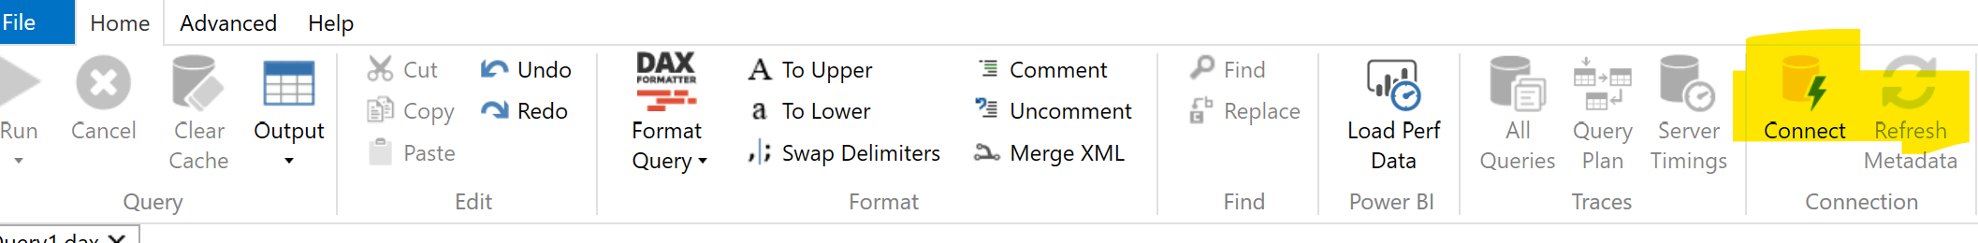

You can confirm that it is connected if the tables show up:

Next you can start a Profiler Instance under the advanced tab:

In SQL Profiler, select the Aggregate Table Rewrite Events, and the Direct Query Begin and End Events at a minimum.

Click Run on the Profiler. Then on the Power BI Visuals, change a selection, then confirm the profiler picked it up:

